**CENWP-OD-B 12 September 2023**

**MEMORANDUM FOR THE RECORD**

**SUBJECT: 23BON090 MFR AFF Valve 15 Salmonid Mortalities**

On the afternoon of 11 September, Columbia River Inter-Tribal Fish Commission (CRITFC) Biologists notified Bonneville Project Biologists of two salmonid mortalities found on the Valve 15 trash rack in the Adult Fish Facility (AFF). The fish were scanned for PIT tags, inspected, and returned to the river.

1. Species – Salmonid (*Oncorhynchus tshawytscha)*
2. Origin – Unknown
3. Length – in descending order of the picture 67.3 cm, 39.4 cm
4. Marks and tags – Adult Chinook no marks, Jack Chinook adipose fin clip
5. Marks and Injuries found on carcass – General decay
6. Cause and Time of Death – Unknown
7. 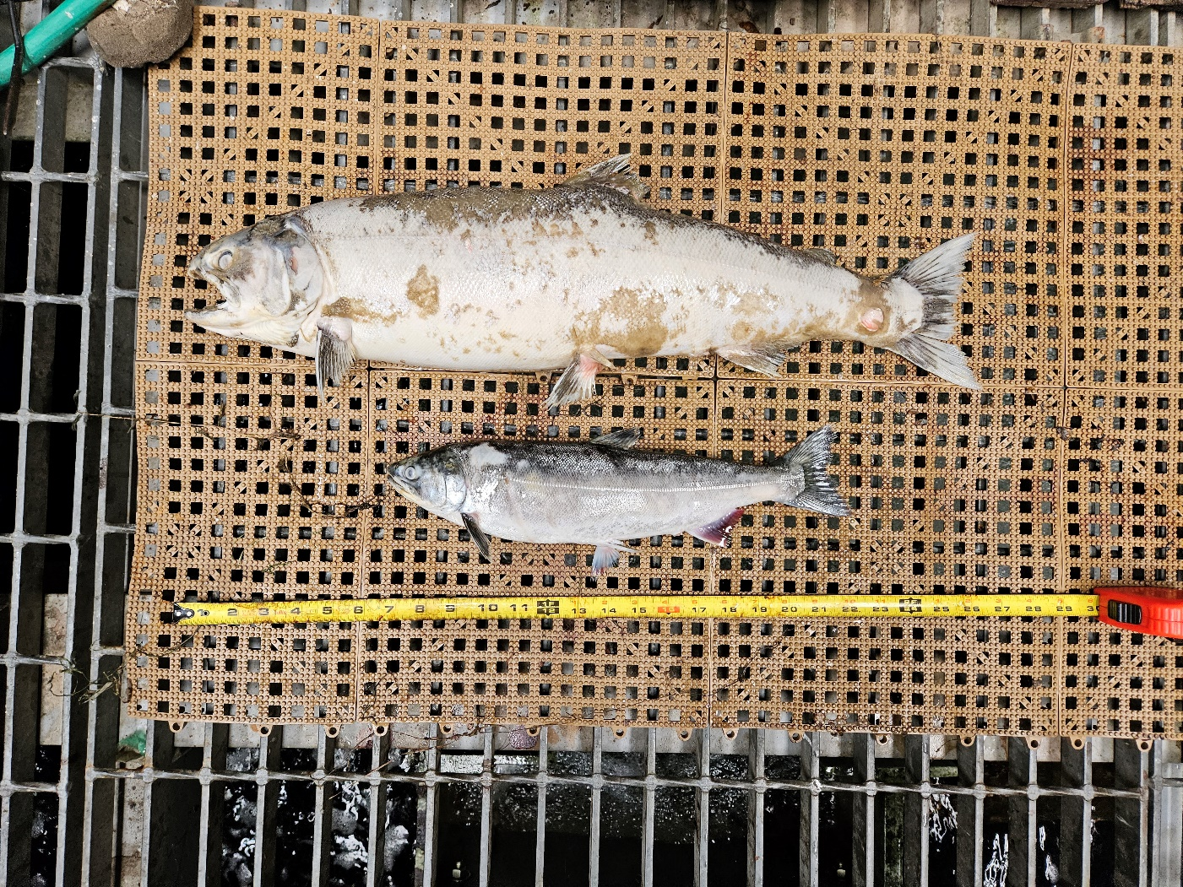Future and Preventative Measures – None

Sincerely,

Bonneville Project Fisheries